|  |  |  |
| --- | --- | --- |
| OCTAVIAN DROOBERS  The Orienteering Club for Warwickshire & Coventry  Affiliated to British Orienteering  www.octavian-droobers.org  **Coventry Weekend of Orienteering**  **University of Warwick Sprints**  **at**  **University Sports Hub, Leighfield Rd**    **Saturday 8th June 2019** | Clubmark_logo_2clr_S web | |
| Level B UKOL  FINAL DETAILS | |  |

Travel: Despite its name, Warwick University is located in Coventry, lying just off the A45 and A46 on the southern side of the city. The Sports Hub postcode is CV4 7EU. There are numerous direction signs to the university all around the area leading to the final approach for everyone along Gibbet Hill Rd. Parking will be signed from the roundabout at the junction with the university’s Leighfield Rd at the southern edge of the campus. Do not use Scarman Rd to approach the Sports Hub. Pedestrians should also use Leighfield Rd as other routes cross the competition area.

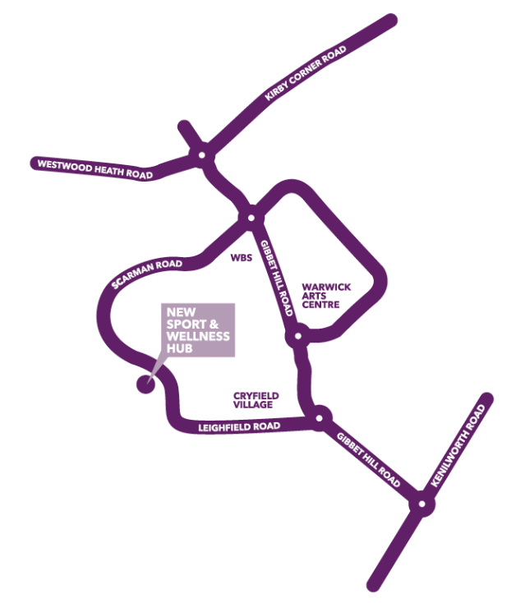

Excellent and extensive local transport links are available from the city centre, station, surrounding city areas and local towns. Visit [www.warwick.ac.uk/about/visiting/](http://www.warwick.ac.uk/about/visiting/) if travelling by bus or train. Assembly is at the new Sports Hub on the western campus. Please use Leighfield Rd (see map) for your final walk to the sports centre. The roundabout with Leighfield Rd is 250m south along Gibbet Hill Rd from the university main bus station and taxi drop-off point. Do not use any of the footpaths across the campus or Scarman Rd as they cross the competition area.

Car Park: Follow the signs along Leighfield Rd to the car park which is just over 200m past the very obvious new sports hub on the left. There is sufficient free parking for the expected number of entries. Please follow the directions of the parking marshals and park closely.

Assembly*:* We are very pleased to be using the impressive new Sports and Wellness Hub which opened April 15th. Assembly is in the multi-purpose suite at the far end of the atrium. The room has direct external access and opens on to a large balcony area with seating if the weather is good. Toilets are adjacent in the atrium which has plenty of space, seats, tables, good internet access and also offers superb viewing areas for the various sports halls including a very large indoor climbing area open to the atrium. The university will be providing a refreshment van with teas, coffees, sandwiches and snacks.

Visit <https://warwick.ac.uk/services/sport/hub/> to view the new centre.

Times: Entry on day & enquiries from 10.00 to 12.00

Start times from 11.00 to 12.30 & 13.15 to 14.45

Race 1 will close at 13.00 & race 2 at 15.15

Entries: Entries on-line at <https://www.sientries.co.uk/event.php?event_id=5554&uid=OD> (closing date June 2nd)

Seniors Weekend £ 22.00: Day £ 12.50

Juniors Weekend £ 10.00: Day £ 6.00

SIAC hire Weekend £ 4.60: Day £ 2.70 - free SI swap for juniors

Entry on the Day Fees: Entry on the day will be subject to map availability.

Seniors £ 13.50

Juniors £ 7.00

SIAC hire £ 2.70 – limited availability on the day

*Entrants who are not BOF members will be charged a £20 refundable deposit for SIAC hire*

Electronic punching: The SIAC contactless electronic punching system will be used. A demonstration control will be available in the assembly area. It is the competitor’s responsibility to ensure that their unit has registered at each control, start and finish. Standard SI cards can also be used. The start and finish controls will need to be punched. Any hired SIACs that are not returned on the day will be charged at £60.

Terrain: The competition area is wholly on campus which is largely flat with some banks and stairs. There is the usual mix of urban campus terrain with teaching, accommodation and research buildings. There are uncrossable water features in various places. Surfaces will be paved, hardcore, grass and a small amount of woodland. Both courses cross campus roads several times. Traffic is expected to be light and slow moving but care must be taken at all times.

Race 1 is on the western campus which is more open. The central and eastern campus, used for Race 2, is a far more complex urban environment with some intricate navigation choices to be made. Taken together, the two races will offer a wide range of sprint orienteering challenges.

There is a public road crossing on the walk to the start and back from the finish. This road, although speed restricted to 20mph, can be quite busy at times and children should be accompanied.

Competitor restrictions: All arriving competitors should use Leighfield Rd to reach assembly as controls will be located throughout the campus. Once competitors have completed Race 1, these restrictions are lifted on the western campus. However, the restrictions still apply to the eastern campus until after competitors have completed their second run.

Course Details:

Course details for each race, subject to final controlling, are shown in the following table. Please note that actual distances run will be significantly longer.

|  |  |  |  |  |  |
| --- | --- | --- | --- | --- | --- |
| Course No | Classes | Race 1 Distance | Race 1 Controls | Race 2 Distance | Race 2 Controls |
| 1 | M16, M18, M20, M21, M35, M40 | 2.7 | 18 | 3.3 | 26 |
| 2 | W16, W18, W20, W21, W35, M45, M50 | 2.3 | 15 | 2.8 | 25 |
| 3 | W40, W45, W50, M14, M55, M60 | 2.0 | 15 | 2.5 | 19 |
| 4 | W12, W14, W55, W60, W65, M12, M65, M70 | 1.7 | 14 | 1.9 | 19 |
| 5 | W70, W75, W80, W85, M75, M80, M85, Newcomers | 1.5 | 11 | 1.7 | 14 |
| 6 | W10, M10 | 1.2 | 12 | 1.6 | 14 |

Juniors: Juniors are advised to run in their age appropriate class.

New to Orienteering: You can enter any course although we recommend course 5. You may wish to do a longer course if you are a regular runner and a capable map reader.

Map: Surveyed and redrawn by Bruce Bryant in 2019. Final mapping in late May to capture the latest possible position on the numerous construction sites that spring up on campus. All maps at 1:4000 scale and printed on waterproof paper.

Control Descriptions: Pictorial control descriptions will be printed on the front of the map for all courses. Loose control descriptions will be available in the start lanes. Text descriptions will be available for newcomers on courses 5 & 6.

Start: Race 1 start is 50m from assembly. Race 2 start is 770m. We are using a timed start although we may allow queueing starts on the day on courses where entry numbers are low. Call up is at your start time minus 4 minutes. Clear and check station at -4 mins. Loose control descriptions will be available at -3 minutes. Blank maps displayed at -2 minutes. Late arrivals report to the start marshal who will allocate you a start time when there is a gap available. All starters must punch the start control. It is a competitor responsibility to ensure that their SIAC registers (flashing red light and beep sound) at the start, finish and at all controls.

Finish & Download: Race 1 finish is 200m from assembly while Race 2 finish is 890m. All competitors must punch to finish. When you have finished your runs, please go directly to Download at Assembly.

Compulsory Safety Check: There will be an electronic safety check at -4 minutes. This will record all starters and will be used at download to ensure that all competitors are accounted for. IT IS THEREFORE ESSENTIAL THAT ALL COMPETITORS WHO START REPORT TO DOWNLOAD EVEN IF THEY DO NOT COMPLETE THEIR COURSE.

Safety and First Aid: All competitors take part at their own risk. They are responsible for their own safety and that of fellow competitors and members of the public. First Aid will be available in the Assembly area. The nearest A & E is at University Hospital, Clifford Bridge Rd, Coventry CV2 2DX (GR SP377804) which is 4 miles from the competition area.

The Event Risk Assessment is available at Enquiries for you to read any information about event specific risks. If you become lost please ask for directions back to the new Sports Hub and proceed to download.

*In the unlikely event that an ambulance needs to be directly summoned via 999, University security must be informed of the exact location of the illness/injury as they will have to direct the ambulance to where it is required when it arrives on campus. University security can be reached via race assembly on 07703 717716 or contacted directly on 02476 522222. These telephone numbers will be printed on competition maps.*

Insurance: British Orienteering members will be covered by British Orienteering Public Liability Insurance. All other competitors will be covered by that public liability insurance for a maximum of three British Orienteering registered events. Joining Octavian Droobers includes British Orienteering membership.

Photography: Steve Rush (BOK) will be taking photos of competitors during the competition. If you object to having your, or your child's, photo published after the event, please inform the organiser.

Facilities: Toilets are available in the Sports Hub

Traders: Ultrasport and catering outside the Sports Hub

Organiser: Keith Willdig OD – keith.willdig@btconnect.com 01455 614845 07850 274610 (before 8pm)

Planner: Anne Straube OD

Controller: Peter Hornsby LEI

More info: Occasionally circumstances may force late changes. Please check on the club website [www.octavian-droobers.org](http://www.octavian-droobers.org) a few days before the event.