|  |  |  |
| --- | --- | --- |
| OCTAVIAN DROOBERS  The Orienteering Club for Warwickshire & Coventry  Affiliated to British Orienteering  www.octavian-droobers.org  **Coventry Weekend of Orienteering**  **University of Warwick Sprints**  **at**  **University Sports Hub, Leighfield Rd**    **Saturday 8th June 2019** | Clubmark_logo_2clr_S web | |
| Level B UK Orienteering League  INITIAL DETAILS  *Highlighted items are subject to change. Check final details in the week before the event* | |  |

Travel: Despite its name, Warwick University is located in Coventry, lying just off the A45 and A46 on the southern side of the city. The Sports Hub postcode is CV4 7EU but follow the directions below when close to the university. The final approach for everyone will be along Gibbet Hill Rd to a roundabout at its junction with the university’s Leighfield Rd at the southern edge of the campus Parking will be signed from Leighfield Rd. Do not use Scarman Rd to approach the Sports Hub.

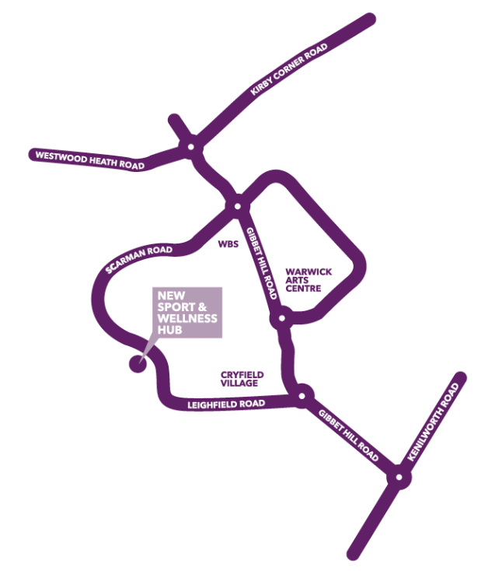The best approach from the south and M40 is via the A46. From the M40/A46 junction, take the A46 north to the 4th exit signed University of Warwick and Stoneleigh. Turn left at the junction and continue over the roundabout in two hundred metres for 2km to the roundabout at the junction with the A429 Kenilworth Rd (see map). Continue straight across this island into Gibbet Hill Rd and then a further 1.0km to the next roundabout which is with the university’s Leighfield Rd from where parking will be signed.

Traffic from other directions is advised to make its final approach along the A45 to the A45/A429 junction. At the lights on the A45/A429 junction, take the A429 south, signed for Kenilworth. Travel about 2.0km south to the first traffic island where you turn right into Gibbet Hill Rd (see map) and then a further 1.0km to the roundabout with the university’s Leighfield Rd from where parking will be signed.

The university has a sprawling campus with numerous sign posts in the surrounding areas, some of which will take a more complex approach and route you to different parts of the campus. If you do end up approaching from a different direction, Gibbet Hill Rd is the main public road through the campus. Travel on it to the roundabout on the southern side of the campus where you will find Leighfield Rd and parking signage.

Excellent and extensive local transport links are available from the city centre, station, surrounding city areas and local towns. Visit [www.warwick.ac.uk/about/visiting/](http://www.warwick.ac.uk/about/visiting/) if travelling by bus or train. Assembly is at the new Sports Hub which lies on the western campus. Please use Leighfield Rd (see map) for your final walk to the sports centre. Leighfield Rd is off the traffic island about 150m south along Gibbet Hill Rd from the university main bus-station and taxi drop-off point. Do not use any of the footpaths across the campus or Scarman Rd as they cross the competition area.

Car Park: Follow the signs along Leighfield Rd to the car park which is just over 200m past the very obvious new sports hub on the left. There is sufficient free parking for the expected number of entries but if numbers are higher, we will overflow into the main sports hub car park which is pay and display. *Additional parking will be available if there is a large number of entries. Please contact organiser for details of camper van or large vehicle parking.*

Assembly*:* We are very pleased to be using the impressive new sports hub which only opened on April 15th. Assembly is in the multi-purpose suite which has direct external access as well as via the main atrium. The room opens on to a large open-air balcony area with seating if the weather is good. A café and toilets are adjacent in the atrium which has plenty of space, seats, tables, good internet access and also offers superb viewing areas for the various sports halls including a very large indoor climbing area open to the atrium. There is plentiful changing and lockers are available to use with a £1 coin. The sports centre is open to members of the public so it is available for you to use as a wind-down after your runs! Visit <https://warwick.ac.uk/services/sport/hub/> to view the new centre.

Times: *Entry on day & enquiries provisionally from 10.00 to 12.00*

*Start times from 11.00 to 12.30 & 13.15 to 14.45*

*Race 1 will close at 13.00 & race 2 at 15.15*

Entries: Entries on-line at <https://www.sientries.co.uk/event.php?event_id=5554&uid=OD> (closing date June 2nd)

Seniors Weekend £ 22.00: Day £ 12.50

Juniors Weekend £ 10.00: Day £ 6.00

SIAC hire Weekend £ 4.60: Day £ 2.70 - free SI swap for juniors

Entry on the Day Fees: Entry on the day will be subject to map availability.

Seniors £ 13.50

Juniors £ 7.00

SIAC hire £ 2.70 - free SI swap for juniors

Entrants who are not BOF members will be charged a £20 refundable deposit for SIAC hire.

Electronic punching: The SIAC contactless electronic punching system will be used. A demonstration control will be available in the assembly area. It is the competitor’s responsibility to ensure that their unit has registered at each control, start and finish. Standard SI cards can also be used. A back-up pin-punch is available on all controls. The start and finish controls will need to be punched.

Terrain: The competition area is wholly on campus which is largely flat with very few hills, some banks and stairs. The morning race is largely on the western campus which is quite open and contains most of the student accommodation with many well-maintained grassy areas surrounding the bedroom blocks. The eastern campus, mainly used for the second race, is a far more complex urban environment with some intricate navigation choices to be made. Together, the two races will offer a wide range of sprint orienteering technical challenges. Traffic on campus is generally very light and speed restricted throughout. There is a public road separating the two halves which can be crossed at several places. The public road has a 20m.p.h. speed restriction but younger juniors may need to be supervised at the crossing point.

Competitor restrictions: Competitors should use Leighfield Rd to reach assembly when on campus, both by car and on foot, as controls will be located throughout the campus. Once competitors have completed their first run, these restrictions are lifted on the western campus. However, the restrictions still apply to the eastern campus until after competitors have completed their second run.

Course Details:

*There is considerable construction work underway across the whole campus which is quite dynamic and will impact all courses. Consequently, course planning and final mapping will take place from mid-April onwards. All courses will follow BOF planning guidance on distances and categories which will be specified on the final details.*

|  |  |
| --- | --- |
| Course No | Classes |
| 1 | M16, M18, M20, M21, M35, M40 |
| 2 | W16, W18, W20, W21, W35, M45, M50 |
| 3 | W40, W45, W50, M14, M55, M60 |
| 4 | W14, W55, W60, W65, M12, M65, M70 |
| 5 | W70, W75, W80, W85, M75, M80, M85, W12, Newcomers |
| 6 | W10, M10 |

Juniors: Juniors should run in their age appropriate class.

New to Orienteering: You can enter any course although we recommend course 5. You may wish to do a longer course if you are a regular runner and a capable map reader.

Map: Surveyed and redrawn by Bruce Bryant in 2019 using the new ISSprOM2019 specification. Final mapping will take place in April in order to properly capture the latest position on the numerous construction sites on campus. All maps at 1:4000 scale and printed on waterproof paper.

Control Descriptions: Control descriptions will be printed on the map. Loose control descriptions will be available in the start lanes. Text descriptions will be available for newcomers on courses 5 & 6.

Start: *The start locations will be described in the final details.* Call up is at your start time minus 4 minutes. Clear and check station at -4 mins. Loose control descriptions will be available at -3 minutes. Blank maps displayed at -2 minutes. It is a timed start. Late arrivals report to the start marshal who will allocate you a start time when there is a gap available. All starters must punch the start control. It is a competitor responsibility to ensure that their SIAC registers (flashing red light and beep sound) at the start, finish and at all controls.

Finish & Download: *The finish locations will be described in the final details.* When you have finished your run please go directly to Download at Assembly.

Compulsory Safety Check: There will be an electronic safety check at -4 minutes. This will record all starters and will be used at download to ensure that all competitors are accounted for. IT IS THEREFORE ESSENTIAL THAT ALL COMPETITORS WHO START REPORT TO DOWNLOAD EVEN IF THEY DO NOT COMPLETE THEIR COURSE.

Safety and First Aid: All competitors take part at their own risk. They are responsible for their own safety and that of fellow competitors and members of the public. First Aid will be available in the Assembly area. The nearest A & E is at University Hospital, Clifford Bridge Rd, Coventry CV2 2DX(GR SP377804) which is 4 miles from the competition area.

The Event Risk Assessment is available at Enquiries for you to read any information about event specific risks. If you become lost please ask for directions back to the new Sports Hub and proceed to download.

*In the unlikely event that an ambulance needs to be directly summoned via 999, University security also need to be informed of the exact location of the illness/injury as they will have to direct the ambulance to where it is required when it reaches the campus. University security can be reached via race assembly on 07703 717716 or contacted directly on 02476 522222. These telephone numbers will be printed on competition maps.*

Insurance: British Orienteering members will be covered by British Orienteering Public Liability Insurance. All other competitors will be covered by that public liability insurance for a maximum of three British Orienteering registered events. Joining Octavian Droobers includes British Orienteering membership.

Photography: Steve Rush (BOK) will be taking photos of competitors during the competition. If you object to having your or your child's photo published after the event, please inform the organiser.

Facilities: Toilets are available in the Sports Hub

Traders: Ultrasport and catering inside the Sports Hub

Organiser: Keith Willdig OD – keith.willdig@btconnect.com 01455 614845 07850 274610 (before 8pm)

Planner: Anne Straube OD

Controller: Peter Hornsby LEI

More info: Occasionally circumstances may force late changes. Please check on the club website [www.octavian-droobers.org](http://www.octavian-droobers.org) a few days before the event.